Below you will find how to submit homeless data in 837 file for Inst and Prof, and Health Net ran these samples through translator with no rejects, passed the HIPAA.
Institutional:
The code which indicates if the patient is HOMELESS at the time of discharge. Patients discharged to a shelter should be considered homeless patients. The condition code in loop 2300 HI02 = “17”.
Condition Codes:
17 = HOMELESS Patient

Homeless Patient Address- In the Address
Subscriber Address (loop 2010BA) the N301 can be populated as "UNKNOWN" and also if known a cross street can be populated and N4 Segment Patient City, State, Zip Code can be populated with appropriate receiver understandable information and its corresponding city and state.

HL*2*1*22*1~
SBR*S**1111******HM~
NM1*IL*1*Subscriber Last Name*Subscriber First Name****MI*Subscriber ID~
N3*UNKNOWN~
N4*ELK GROVE*CA*95758~
DMG*D8*Subscriber DOB*Subscriber Gender type~
NM1*PR*2*QMPN HEALTH NET*****PI*954402957~
CLM*1_PATIENT CONTROL# PE*100***21:B:1*Y*A*Y*Y*P~
DTP*434*RD8*20200412-20200412~
CL1*1*1*01~
HI*ABK>R569>>>>>>>U~
HI*APR>R569~
HI*ABF>T43621A>>>>>>>U*ABF>T407X1A>>>>>>>U*ABF>D72829>>>>>>>U*ABF>Z590>>>>>>>U~
HI*BH>11>D8>20200412~
HI*BG>17~⬅==================Condition Code

This sample shows the loop 2010BA N301 address field the word “HOMELESS”. N302 has address with the cross street

HL*2*1*22*1~
SBR*S**1111******HM~
NM1*IL*1*Subscriber Last Name*Subscriber First Name****MI*Subscriber ID~
N3*HOMELESS*CROSS ST J & K STREET~
N4*ELK GROVE*CA*95758~
DMG*D8*Subscriber DOB*Subscriber Gender type~
NM1*PR*2*QMPN HEALTH NET*****PI*954402957~
CLM*1_PATIENT CONTROL# PE*100***21:B:1*Y*A*Y*Y*P~
DTP*434*RD8*20200412-20200412~
CL1*1*1*01~
HI*ABK>R569>>>>>>>U~
HI*APR>R569~
HI*ABF>T43621A>>>>>>>U*ABF>T407X1A>>>>>>>U*ABF>D72829>>>>>>>U*ABF>Z590>>>>>>>U~
HI*BH>11>D8>20200412~
HI*BG>17~⬅==================Condition Code

Link from online on Condition code:
https://medicalbillingrcm.com/ub-04-condition-codes/#Condition_Code_Guidelines_for_D7_D8_and_D9
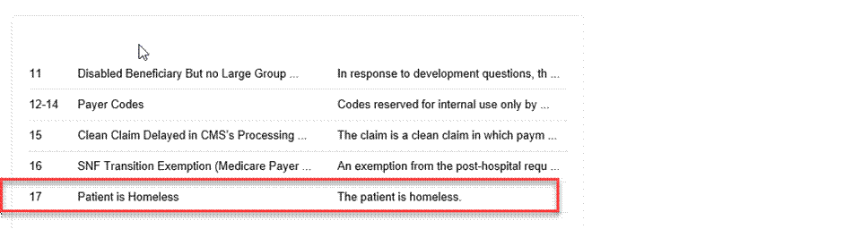

Sample of X837 5010 Mapping guide: showing the HI field- condition code

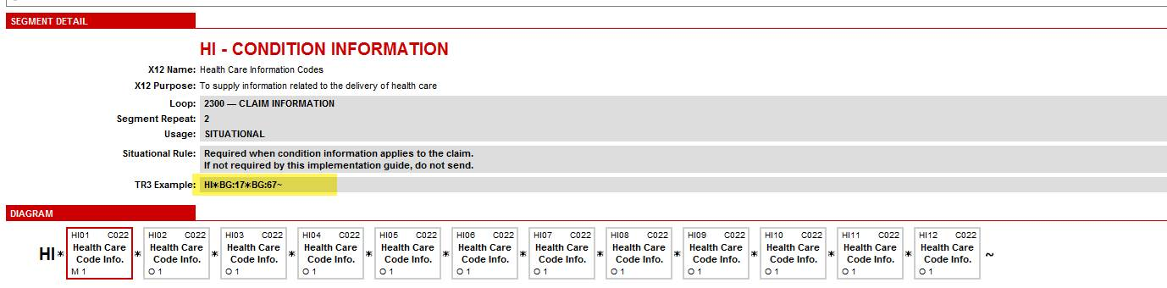

Sample of X837 5010 Mapping guide: showing the Note field

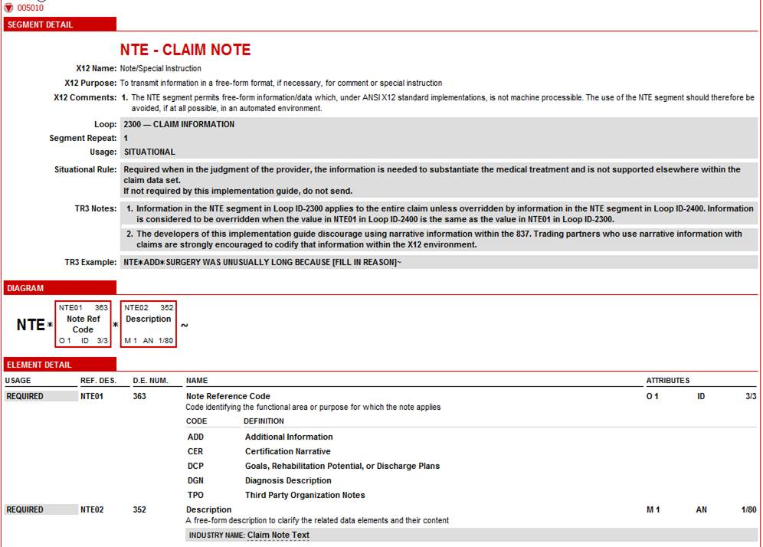

Professional:

Example 1:

In loop 2010BA N301 field has the word “HOMELESS” and N302 has CROSS ST J & K STREET.

HL*2*1*22*0~
SBR*S*18*1111******HM~
NM1*IL*1*Subscriber Last Name*Subscriber First Name****MI*Subscriber ID~
N3*HOMELESS*CROSS ST J & K STREET~
N4*ELK GROVE*CA*95758~
DMG*D8*Subscriber DOB*Subscriber Gender type~
NM1*PR*2*QMPN HEALTH NET*****PI*954402957~
CLM*1_PATIENT CONTROL# PE*100***21:B:1*Y*A*Y*Y*P~

Example 2:

In loop 2010BA N301 address field the word “HOMELESS” can be populated, to indicate the member is homeless. N302 has address
In the loop 2300 NTE field, we can educate the provider/facility that they must add the cross street.

HL*2*1*22*0~
SBR*S*18*1111******HM~
NM1*IL*1*Subscriber Last Name*Subscriber First Name****MI*Subscriber ID~
N3*HOMELESS*120 MASTERS STREET~
N4*ELK GROVE*CA*95758~
DMG*D8*Subscriber DOB*Subscriber Gender type~
NM1*PR*2*QMPN HEALTH NET*****PI*954402957~
CLM*1_PATIENT CONTROL# PE*100***21:B:1*Y*A*Y*Y*P~
AMT*F5*25~
NTE*ADD*CROSS ST J & K STREET~

Sample of X837 5010 Mapping guide: showing the address field

